AN
INTERNSHIP REPORT
ON
GAS AGENCY MANAGEMENT SYSTEM
PROJECT
BY
SASWATI MAHAPATRA

GAS AGENCY MANAGEMENT
SYNOPSIS
The project entitled “Gas Agency” is done to make the manual process
easier by making it a computerized system for billing and maintaining stock.
The Gas Agencies get the order request through phone calls or by
personal from their customers and deliver the gas cylinders to their address
based on their demand and previous delivery date. This process is made
computerized and the customer’s name, address and stock details are stored in a
database. Based on this the billing for a customer is made simple and easier,
since a customer order for gas can be accepted only after completing a certain
period from the previous delivery. This can be calculated and billed easily
through this.
There are two types of delivery like domestic purpose use delivery and
commercial purpose use delivery.
The bill rate and capacity differs for both. This can be easily maintained
and charged accordingly. The stockof gas and all its details are processed
swiftly

1 Introduction
1.1 About the organization
The concern “Radha Gas Agency” deals with the supply of gas for domestic and
commercial purpose. It is situated of at No.134B, Siruvani Main Road, Alandurai,
Coimbatore. The organization was established at 1996 and currently it has carrying out its
duty with a 300 number of workers working in its esteemed campus. They service the
customers based on their needs by serving to home by giving domestic delivery and to
vehicles and shops for commercial purpose. The organization has established well by prompt
delivery and advancement.
1.2 Project Description
The project entitled “Gas Agency” is done to make the manual process easier by
making it a computerized system for billing and maintaining stock.
The Gas Agencies get the order request through phone calls or by personal from their
customers and deliver the gas cylinders to their address based on their demand and previous
delivery date. This process is made computerized and the customer’s name, address and stock
details are stored in a database. Based on this the billing for a customer is made simple and
easier, since a customer order for gas can be accepted only after completing a certain period
from the previous delivery. This can be calculated and billed easily through this.
There are two types of delivery like domestic purpose use delivery and commercial
purpose use delivery. The bill rate and capacity differs for both. This can be easily
maintained and charged accordingly. The stock of gas and all its details are processed swiftly.
The following modules are involved in this project
• Customer Details
• Transaction Details
• Stock Details
• Billing
• Booking

2.SYSTEM STUDY
2.1 EXISTING SYSTEM:
In the existing system, the billing process, receiving order from customers and stock details
are done through manual records.
Whenever a customer makes a demand for gas it is recorded in a separate notebook and the
previous delivery made to the customer is searched and the number of days from that date till
now is calculated. If the number of days is expired only then the order is accepted, if not the
order placed will be rejected. Then the valid order request is request is taken in and a billing
is done manually. The order is for two purposes as domestic and commercial. The billing is
done based on the above two categories and the rate is charged.
Then the stock of cylinders is also maintained in manual records. So while billing this also
has to be taken into account and billed. So this involves a great process and the time is also
wasted.
2.2 PROPOSED SYSTEM:
In the proposed system, the process of billing and maintaining the stock, database of
customers are all made computerized.
Since whenever a customers makes a demand or places an order through phone call or by
personal, it is received and immediately checked by billing. The customer’s name, address,
last date of delivery are all maintained in the database. So when the customer order is
received and billed, the system automatically calculates the number of days from the previous
delivery, if valid the billing can be done, if not the billing cannot be done and the customer
can be informed about it. So the manual process of recording and billing is done easily
without any paper work.
The stock of gas that is recorded and maintained manually is made computerized. So
while billing, based on the stock the billing charge and capacity is made. When the stock
goes below the limit, it can be easily identified. So by this project the process of ordering,
billing and stock maintenance for a gas agency can be processed easily

3 SYSTEM SPECIFICATIONS
3.1 HARDWARE CONFIGURATION
The hardware used for the development of the project is:
PROCESSOR | : | PENTIUM III 866 MHz

RAM | : | 128 MD SD RAM

MONITOR | : | 15” COLOR

HARD DISK | : | 20 GB

FLOPPY DRIVE | : | 1.44 MB

CDDRIVE | : | LG 52X

KEYBOARD | : | STANDARD 102 KEYS

MOUSE | : | 3 BUTTONS

3.2 SOFTWARE CONFIGURATION
The software used for the development of the project is:
OPERATING SYSTEM | : | Windows 2000 Professional

ENVIRONMENT | : | Visual Studio .NET 2002

.NET FRAMEWORK | : | Version 1.0

LANGUAGE | : | Visual Basic.NET

BACKEND | : | SQL SERVER 2000

4 LANGUAGE SPECIFICATIONS
4.1 FEATURES OF VISUAL BASIC. NET
Visual Basic. NET, the latest version of visual basic, includes many new features. The
Visual Basic supports interfaces but not implementation inheritance.
Visual basic.net supports implementation inheritance, interfaces and overloading. In
addition, Visual Basic .NET supports multithreading concept.
COMMON LANGUAGE SPECIFICATION (CLS):
Visual Basic.NET is also compliant with CLS (Common Language Specification) and
supports structured exception handling. CLS is set of rules and constructs that are
supported by the CLR (Common Language Runtime). CLR is the runtime
environment provided by the .NET Framework; it manages the execution of the code
and also makes the development process easier by providing services.
Visual Basic.NET is a CLS-compliant language. Any objects, classes, or components
that created in Visual Basic.NET can be used in any other CLS-compliant language.
In addition, we can use objects, classes, and components created in other CLS-
compliant languages in Visual Basic.NET .The use of CLS ensures complete
interoperability among applications, regardless of the languages used to create the
application.
IMPLEMENTATION INHERITANCE:
Visual Basic.NET supports implementation inheritance. This means that, while
creating applications in Visual Basic.NET, we can drive from another class, which is
know as the base class that derived class inherits all the methods and properties of the
base class. In the derived class, we can either use the existing code of the base class or
override the existing code. Therefore, with help of the implementation inheritance,
code can be reused.
CONSTRUCTORS AND DESTRUCTORS:
Constructors are used to initialize objects, whereas destructors are used to destroy
them. In other words, destructors are used to release the resources allocated to the
object. In Visual Basic.NET the sub finalize procedure is available. The sub finalize
procedure is used to complete the tasks that must be performed when an object is
destroyed. The sub finalize procedure is called automatically when an object is
destroyed. In addition, the sub finalize procedure can be called only from the class it
belongs to or from derived classes.

GARBAGE COLLECTION:
Garbage Collection is another new feature in Visual Basic.NET. The .NET
Framework monitors allocated resources, such as objects and variables. In addition,
the .NET Framework automatically releases memory for reuse by destroying objects
that are no longer in use. In Visual Basic.NET, the garbage collector checks for the
objects that are not currently in use by applications. When the garbage collector comes
across an object that is marked for garbage collection, it releases the memory occupied
by the object.
OVERLOADING:
Overloading is another feature in Visual Basic.NET. Overloading enables us to define
multiple procedures with the same name, where each procedure has a different set of
arguments. Besides using overloading for procedures, we can use it for constructors
and properties in a class.
MULTITHREADING:
Visual Basic.NET also supports multithreading. An application that supports
multithreading can handle multiple tasks simultaneously, we can use multithreading to
decrease the time taken by an application to respond to user interaction. To decrease
the time taken by an application to respond to user interaction, we must ensure that a
separate thread in the application handles user interaction.
STRUCTURED EXCEPTION HANDLING:
Visual Basic.NET supports structured handling, which enables us to detect and
remove errors at runtime. In Visual Basic.NET, we need to use Try…Catch…Finally
statements to create exception handlers. Using Try…Catch…Finally statements, we
can create robust and effective exception handlers to improve the performance of our
application.
THE .NET FRAMEWORK
The .NET Framework is a new computing platform that simplifies application
development in the highly distributed environment of the Internet.
OBJECTIVES OF. NET FRAMEWORK:
1.To provide a consistent object-oriented programming environment whether object
codes is stored and executed locally on Internet-distributed, or executed remotely.
2.To provide a code-execution environment to minimizes software deployment and
guarantees safe execution of code.

3. Eliminates the performance problems.
There are different types of application, such as Windows-based applications and
Web-based applications.
To make communication on distributed environment to ensure that code be accessed
by the .NET Framework can integrate with any other code.
VISUAL STUDIO .NET
Visual Studio .NET is a complete set of development tools for building ASP
Web applications, XML Web services, desktop applications, and mobile applications
In addition to building high-performing desktop applications, you can use Visual
Studio's powerful component-based development tools and other technologies to
simplify team-based design, development, and deployment of Enterprise solutions.
Visual Basic .NET, Visual C++ .NET, and Visual C# .NET all use the same integrated
development environment (IDE), which allows them to share tools and facilitates in
the creation of mixed-language solutions. In addition, these languages leverage the
functionality of the .NET Framework and simplify the development of ASP Web
applications and XML Web services.
Visual Studio supports the .NET Framework, which provides a common language
runtime and unified programming classes; ASP.NET uses these components to create
ASP Web applications and XML Web services. Also it includes MSDN Library,
which contains all the documentation for these development tools.

INTRODUCTION TO SQL SERVER
Sql Server is comprehensive operating environment that packs h power of
mainframe relation database management system into user’s microcomputer. It
provides a set of functional program that user can use as tools to build structures
and perform tasks. Because applications are developed on Sql Server are completely
portable to the other versions of the programmer can create a complex application in
a single user, environment and then move it to a multi-user platform. Users do not
have to be an expert to appreciate Sql Server but the better user understands the
program, the more productively and creatively he can use the tools it provides.
Relational Database Management System
➢ Sql Server the right tool
➢ Sql Server gives you High Capacity
➢ Database management tools
➢ Structure of Sql Server Database
Sql Server database can be describe at two different levels
➢Physical Structure
➢Logical Structure
Physical Structure:
a) One or more data files
b) Two or more log files
c) One control file
Logical Structure
a) Table spaces
b) Segments
c) Extents
d) Data Blocks
The data files contain all user data in terms of tables, index and views. The log files
contain the information to open and be recovered, of undone after a transaction
(Rollback).
The control file physical data, media information to open and manage data files. If
the control file is damaged the server will not be able to open or use the database
even if the database is undamaged.

5 SYSTEM DESIGN
5.1 INPUT DESIGN
A screen is an actually a display station that has a buffer for storing data. The main
objective of screen design is for simplicity, accurate and quick data capture or entry.
Our guidelines are:
• Use the same format throughout the project.
• Allow ample space to avoid data over crowding because it cause
eyestrain and may reduce the interest of the user.
• Use easy tolerant and consistent term such as “add”, “delete” and
“close”.
5.2 OUTPUT DESIGN
Report design is very important concept in the computerized system, without reliable output
the user may feel the entire system is unnecessary and avoids using it. The proper output
design is important in any system and facilitates effective decision making. The report design
of this system includes the following reports.
5.3 TABLE DESIGN
Database design is a collection of interactive data store. It is an effective method of
defining, storing and retrieving the information in the database. Multiple application and
users can use the data contained in the database. It prevents fraudulent and unauthorized users
from accessing data and ensures the privacy of data.
The ERD to relational scheme mapping is done in order to make the most efficient
use of table space. The relations of the scheme are converted into table and key attributes are
converted into primary keys. The various tables that are used in the system are derived from
the Entity Relationship Diagram. The tables are maintained are developer table and mining
table.

Table Design
Billing Details
Column Name | Data Type | Description
slno | int | Serial No
consno | int | Consumer No
cylintype | char(10) | Cylinder Type
bkdate | datetime | Booked Date
deldate | datetime | Delivery Date
amt | float | Amount
Customer Details
Column Name | Data Type | Description
consno | int | Consumer No
cltype | nchar(10) | Cylinder Type
noofcl | int | No of Cylinder
dtofconn | datetime | Date of Connection
consname | nchar(20) | Consumer Name
addr | varchar(50) | address
pin | int | Pin Code
phone | int | Phone No
mobile | bigint | Mobile No
cdate | datetime | Connection Date
Price Details
Column Name | Data Type | Description
cylty | varchar(20) | Cylinder Type
price | float | Price
Stock Details
Column Name | Data Type | Description
dt | datetime | Date
storeccom | int | Stock received commercial
storecdom | int | Stock received domestic
defcomm | int | Defective in commercial
defdom | int | Defective in Domestic
cstocom | int | Current stock in commercial
cstodom | int | Current stock in domestic

Transaction Details
Column Name | Data Type | Description
slno | nvarchar(50) | Serial no
consno | int | Consumer no
cylntype | varchar(15) | Cylinder type
bkdt | datetime | Booked date
deldt | nvarchar(50) | Deliver date
remark | varchar(25) | remarks
Transaction Stock Details
Column Name | Data Type | Description
commstk | int | Commercial stock
domestk | int | Domestic stock


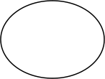




5.4 DATA FLOW DIAGRAM
InValid | Process | Login DB
  Login
Valid
 | Customer DB
  Customer Details

 | Stock DB
  Stock Details

 | Transaction DB
  Transaction

 | Billing DB
  Billing
Reports

6. SYSTEM TESTING AND MAINTENANCE
Testing is vital to the success of the system. System testing makes a logical
assumption that if all parts of the system are correct, the goal will be successfully
achieved. In the testing process we test the actual system in an organization and gather
errors from the new system operates in full efficiency as stated. System testing is the
stage of implementation, which is aimed to ensuring that the system works accurately
and efficiently.
In the testing process we test the actual system in an organization and gather errors
from the new system and take initiatives to correct the same. All the front-end and
back-end connectivity are tested to be sure that the new system operates in full
efficiency as stated. System testing is the stage of implementation, which is aimed at
ensuring that the system works accurately and efficiently.
The main objective of testing is to uncover errors from the system. For the
uncovering process we have to give proper input data to the system. So we should
have more conscious to give input data. It is important to give correct inputs to
efficient testing.
Testing is done for each module. After testing all the modules, the modules are
integrated and testing of the final system is done with the test data, specially designed
to show that the system will operate successfully in all its aspects conditions. Thus the
system testing is a confirmation that all is correct and an opportunity to show the user
that the system works. Inadequate testing or non-testing leads to errors that may
appear few months later. This will create two problems
Time delay between the cause and appearance of the problem.
The effect of the system errors on files and records within the system.
The purpose of the system testing is to consider all the likely variations to which it
will be suggested and push the system to its limits.
The testing process focuses on logical intervals of the software ensuring that all the
statements have been tested and on the function intervals (i.e.,) conducting tests to
uncover errors and ensure that defined inputs will produce actual results that agree
with the required results.
Testing has to be done using the two common steps Unit testing and Integration
testing.
In the project system testing is made as follows:
The procedure level testing is made first. By giving improper inputs, the errors
occurred are noted and eliminated.

This is the final step in system life cycle. Here we implement the tested error-free
system into real-life environment and make necessary changes, which runs in an
online fashion. Here system maintenance is done every months or year based on
company policies, and is checked for errors like runtime errors, long run errors and
other maintenances like table verification and reports.
6.1. UNIT TESTING:
Unit testing verification efforts on the smallest unit of software design, module. This is
known as “Module Testing”. The modules are tested separately. This testing is carried out
during programming stage itself. In these testing steps, each module is found to be working
satisfactorily as regard to the expected output from the module.
6.2. INTEGRATION TESTING:
Integration testing is a systematic technique for constructing tests to uncover error associated
within the interface. In the project, all the modules are combined and then the entire
programme is tested as a whole. In the integration-testing step, all the error uncovered is
corrected for the next testing steps.
6.3.VALIDATION TESTING:
To uncover functional errors, that is, to check whether functional characteristics
confirm to specification or not.
6.4. OUTPUT TESTING:
The output generated or displayed by the system, under consideration is tested asking the
users about the format required by them. Here, the output is considered into two ways: one is
on the screen and other is the format.
The output format on the screen is found to be correct as the format design according to the
user needs. For the hard copy also, the output comes out as specified by the user. Hence the
output testing didn’t result in any correction in the system.

6.5. USER ACCEPTANCE TESTING:
User acceptance of a system is the factor for the success of any system. The system under
consideration is tested for user acceptance by constantly keeping in touch with the
perspective system users at the time developing and making of testing automation tool.
The testing of the software began along with coding. Since the design was fully object-
oriented, first the interface were developed and tested. Then unit testing was done for every
module in the software for various inputs, such that each line of code is at least once
executed.
After all modules were coded, the integration test was carried out. Some minor errors were
found in the output at the earlier stage and each of them was corrected. In the implementation
of user interface part no major errors were found. After the software was completely
developed, the testing was done. The output of the system is correct and accurate during the
time of demonstration. We proceed the testing process in this way
Each and every program units are tested which is known as unit testing
Then, we check the logic of the program, were the input of one would affect the output of the
order, which is called as series testing
We test the inputs to ensure that they do infant process contain transactions according to
specification. This testing is named as positive testing.
Execution a program with the intention of finding errors does system testing.
We run the system with live data by the actual user. This known as acceptance testing.
The security level of the system is tested which prevents unauthorized access to the system
and records the user names that performed any change to the records. This kind of test is
known as security testing.
TESTING OBJECTIVE
Testing is a process of executing a programme with intention of finding an error. A good test
case is one that has a high probability of finding an as-get undiscovered error. A successful

test is that in which no error are found. The objective is to design tests that systematically
uncover different classes of error and do with a minimum amount of time and effort.
SYSTEM SECURITY
Any system that is developed should be secured and protected against possible hazards. The
software takes care to see that in the event of interruption due to power failure or voltage
fluctuate the data in the file all not erased. Passwords can be set such that the user should
enter it before the software can be seen. It is the most commonly used means for
authenticating the identify of people. Password all set such that it is hard to guess and easy to
remember..

8.CONCLUSION
We may conclude that this software created will definitely find a good market in the
Gas Agency to its maximum extend.

7.coding
HTML:-
<!DOCTYPE html>
<html>
<head>
<title>Gas Agency Management</title>
<link rel="stylesheet" href="style.css">
</head>
<body>
<h2>Gas Agency Management System</h2>

<input id="name" placeholder="Consumer Name">
<input id="count" type="number" placeholder="Cylinder Count">
<select id="status">
<option>Booked</option>
<option>Delivered</option>
</select>
<button onclick="addGas()">Submit</button>

<h3>Gas Records</h3>
<ul id="list"></ul>

<script src="script.js"></script>
</body>
</html>

JAVASCRIPT: -
// Gas Agency Management System (Java Console Application)
// Suitable for college projects & viva

import java.util.*;

class Consumer {
int consumerId;
String name;
int cylinders;
String status;

Consumer(int consumerId, String name, int cylinders, String status) {
this.consumerId = consumerId;
this.name = name;
this.cylinders = cylinders;
this.status = status;
}
}

public class GasAgencyManagementSystem {

static Scanner sc = new Scanner(System.in);
static ArrayList<Consumer> consumers = new ArrayList<>();

public static void main(String[] args) {
int choice;

do {

System.out.println("\n--- GAS AGENCY MANAGEMENT SYSTEM ---");
System.out.println("1. Add Consumer Booking");
System.out.println("2. View All Bookings");
System.out.println("3. Update Booking Status");
System.out.println("4. Delete Booking");
System.out.println("5. Exit");
System.out.print("Enter choice: ");

choice = sc.nextInt();

switch (choice) {
case 1:
addBooking();
break;
case 2:
viewBookings();
break;
case 3:
updateStatus();
break;
case 4:
deleteBooking();
break;

case 5:
System.out.println("Thank you!");
break;
default:
System.out.println("Invalid choice!");
}
} while (choice != 5);
}

static void addBooking() {
System.out.print("Enter Consumer ID: ");
int id = sc.nextInt();
sc.nextLine();

System.out.print("Enter Consumer Name: ");
String name = sc.nextLine();

System.out.print("Enter No. of Cylinders: ");
int cyl = sc.nextInt();

Consumer c = new Consumer(id, name, cyl, "Booked");
consumers.add(c);
System.out.println("Booking Added Successfully!");
}

static void viewBookings() {
if (consumers.isEmpty()) {
System.out.println("No bookings found.");
return;
}

System.out.println("\nID\tName\tCylinders\tStatus");
for (Consumer c : consumers) {
System.out.println(c.consumerId + "\t" + c.name + "\t" + c.cylinders + "\t\t" + c.status);

}
}
static void updateStatus() {
System.out.print("Enter Consumer ID: ");

int id = sc.nextInt();

for (Consumer c : consumers) {
if (c.consumerId == id) {
System.out.print("Enter New Status (Booked/Delivered): ");
c.status = sc.next();
System.out.println("Status Updated Successfully!");
return;
}
}
System.out.println("Consumer not found!");
}

static void deleteBooking() {
System.out.print("Enter Consumer ID: ");
int id = sc.nextInt();

Iterator<Consumer> it = consumers.iterator();
while (it.hasNext()) {
Consumer c = it.next();
if (c.consumerId == id) {
it.remove();
System.out.println("Booking Deleted Successfully!");
return;

}
}
System.out.println("Consumer not found!");
}
}

CSS: -
* {
margin: 0;
padding: 0;
box-sizing: border-box;
font-family: Arial, sans-serif;
}

body {
background-color: #f2f6ff;
display: flex;
justify-content: center;
align-items: center;
min-height: 100vh;
}

.container {
background: #ffffff;
width: 420px;
padding: 25px;
border-radius: 10px;
box-shadow: 0 8px 20px rgba(0, 0, 0, 0.15);
}

h2 {
text-align: center;
margin-bottom: 20px;
color: #2c3e50;

}

input,
select {
width: 100%;
padding: 10px;
margin: 8px 0;
border-radius: 6px;
border: 1px solid #ccc;
font-size: 14px;
}

input:focus,
select:focus {
outline: none;
border-color: #3498db;
}

button {
width: 100%;
padding: 10px;
margin-top: 12px;
background-color: #3498db;
color: white;
border: none;
border-radius: 6px;
font-size: 15px;
cursor: pointer;
}

button:hover {
background-color: #2980b9;
}

ul {
margin-top: 15px;
list-style: none;
}

ul li {
background: #ecf0f1;
padding: 8px;
margin-bottom: 6px;
border-radius: 5px;
font-size: 14px;
}

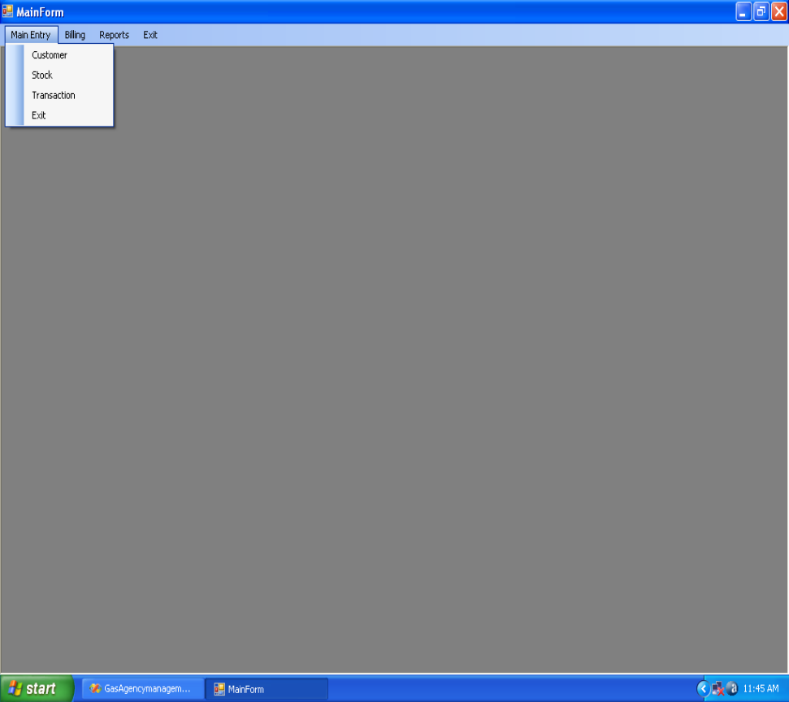

Sample Screen Shot

